Data Uji Program
- Souce Code
data_uji = [

("Bayi", 1),
("Bayi", 4),

("Anak-anak", 7),
("Anak-anak", 10),

("Remaja", 12),
("Remaja", 17),

("Pemuda", 17),
("Pemuda", 22),

("Dewasa", 30),
("Dewasa", 54),

("Lansia", 65),
("Lansia", 75)
]

- Hasil Eksekusi Program
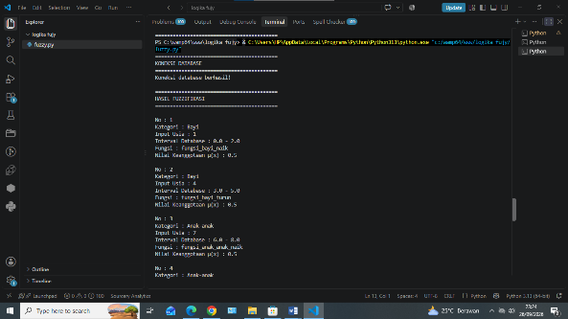 | 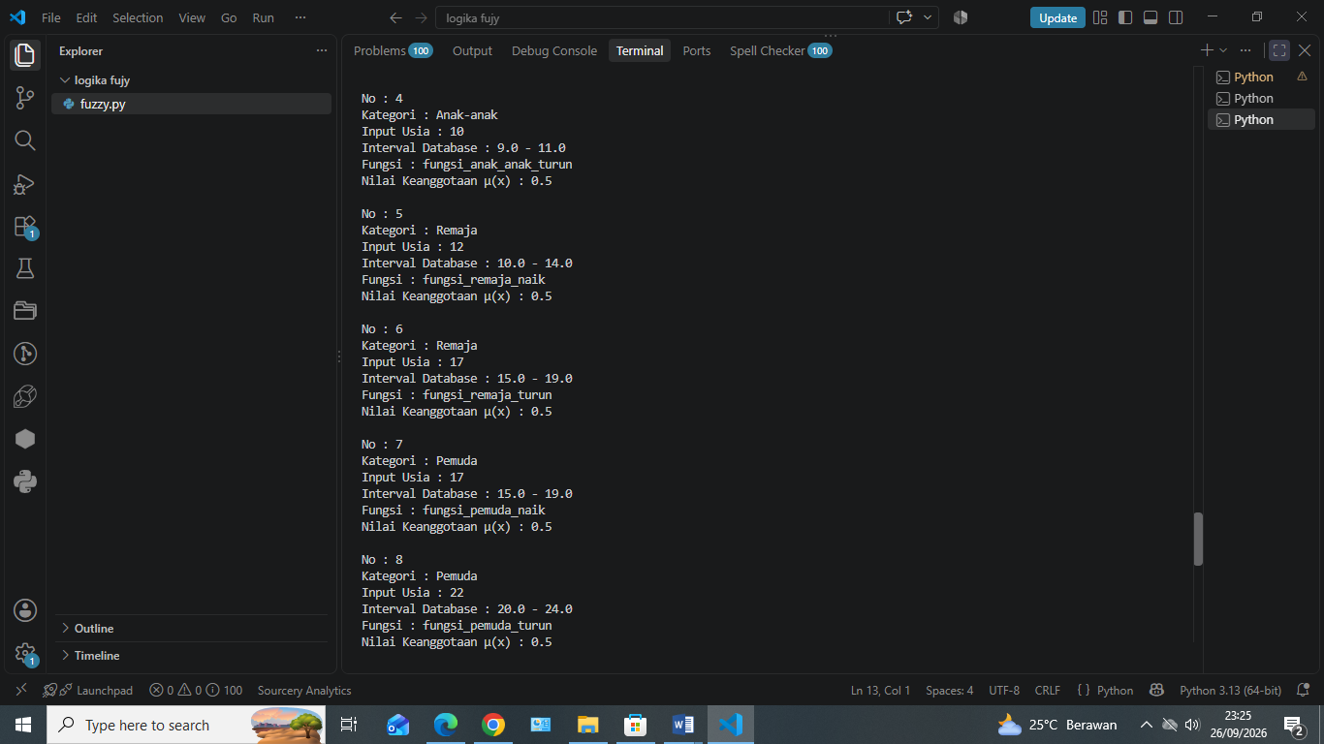
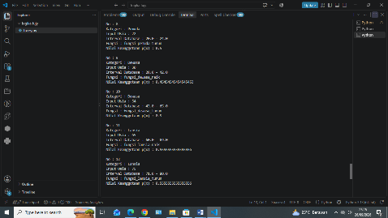 | 